**Experiment No : 8**

**Aim :** To perform SVM classification on A & B Alphabets.

**Theory :**

SVM is a supervised machine learning algorithm which can be used for classification or regression problems. It uses a technique called the kernel trick to transform your data and then based on these transformations it finds an optimal boundary between the possible outputs.

I downloaded Image processing toolbox for this task.

**Dataset used :**

I have used 5 images of A and 5 images of B alphabets & an excel file with feature data of A & B Alphabets.

**Code :**

clc;

clear all;

rng(6,'twister')

D = dir('C:\Users\arjun\Documents\MATLAB\png\*.png');

nfiles = length(D); %calculating the length of the dataset

for i = 1:nfiles

cfilename = D(i).name;

cimg = imread(cfilename);

I = imresize(cimg, [42 32]); %resizing the 'i'th image in the dataset to 42x32 pixels

threshold = graythresh(I); % calculating the threshold value for digitizing each image

I = imbinarize(I,threshold); %quatizing each image using the calculated threshold value

I = reshape(I,7,8,24); %reshaping the image to 24 boxes(features) with 7x8 pixels for each feature

I = mean(mean(I)); %calculating the mean for each featutre; mean(I) calculates the mean for 7x8 pixels for 24 boxes/features and mean(mean(I)) calculates the mean for values per box/feature

X(i,:)=I(:); %storing the 24 feature values of the image in the dataset matrix;

end

y= importdata('label.exp7.xlsx');

rng default

SVMModel = fitcsvm(X,y,'Standardize',true,'KernelFunction','RBF','OptimizeHyperparameters','auto',...

'HyperparameterOptimizationOptions',struct('AcquisitionFunctionName',...

'expected-improvement-plus'))

**Output :**

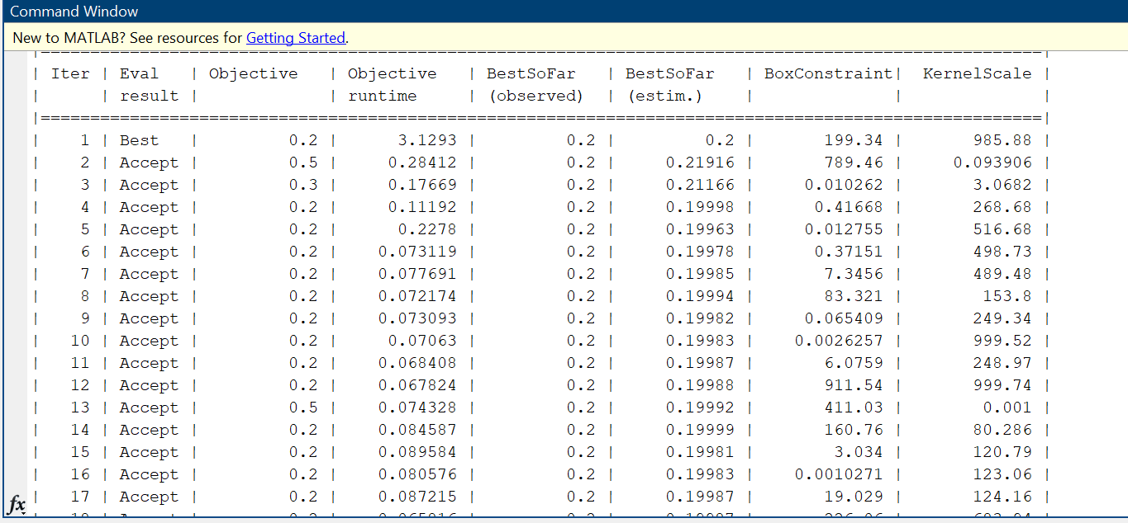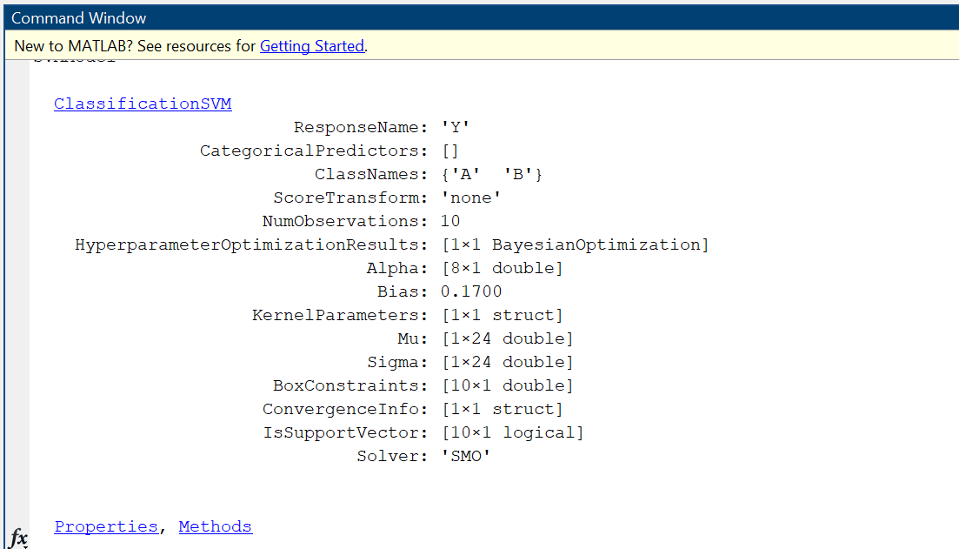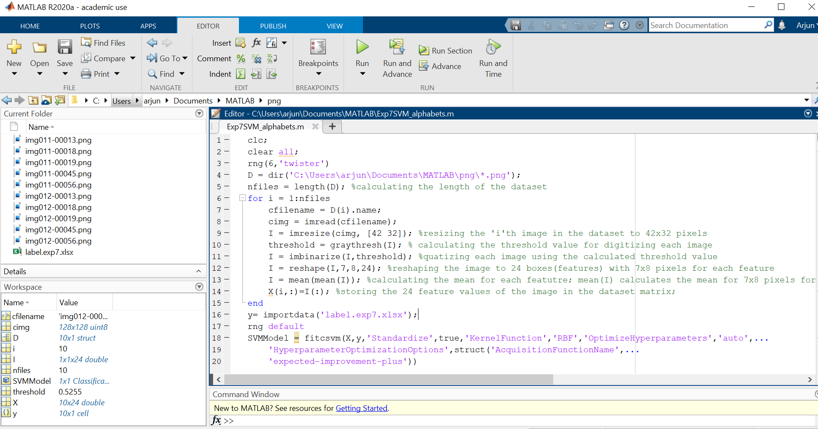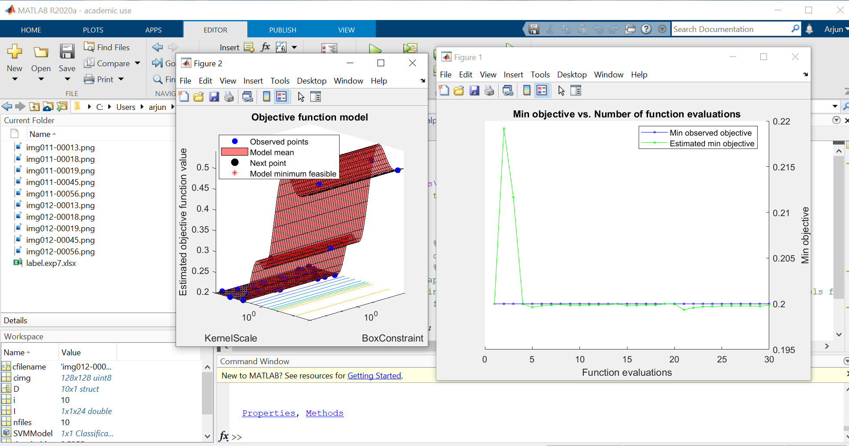

**Conclusion :** Thus, after performing this experiment on Support Vector Machine on English Alphabets I was able to classify 2 alphabets and observe the Objective function model & Min Objective vs No. of function evaluation curve with 10 observations and bias as 0.1700 on MATLAB.